Dehcho Mentor-Apprentice Program
Application Package

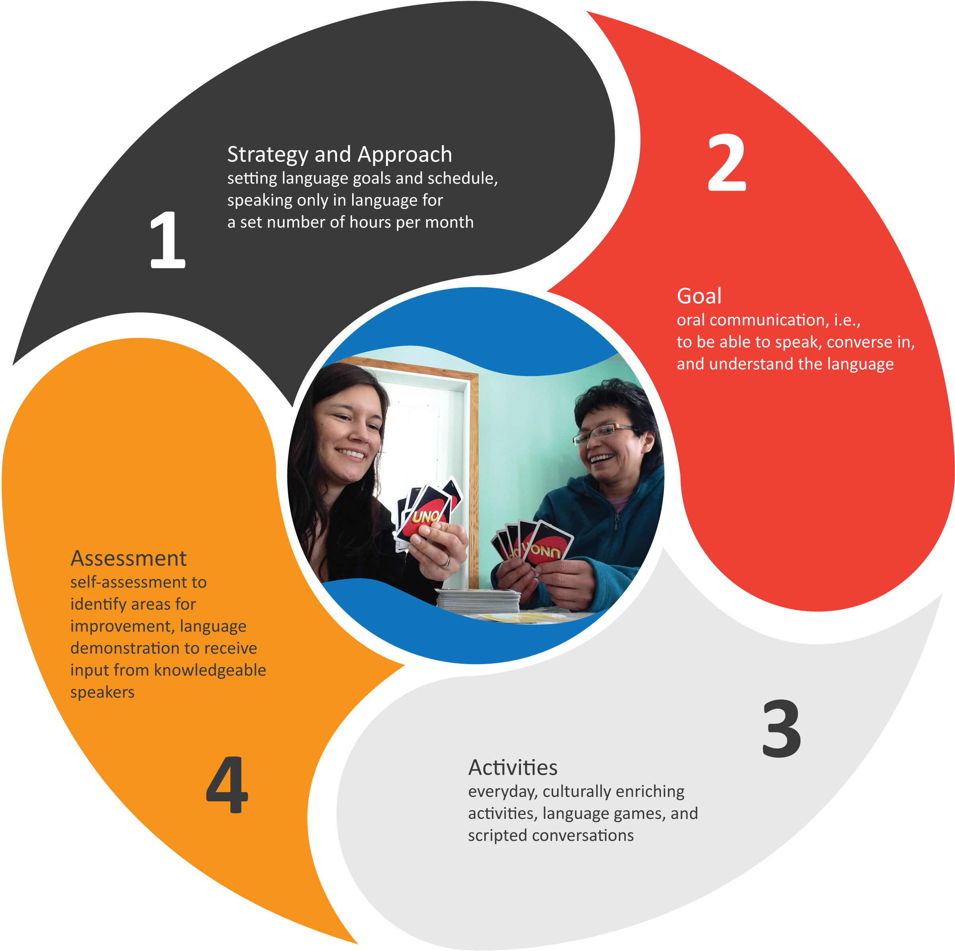

Please submit completed application to:

Violet Jumbo
Language Manager, Dehcho First Nations
Box 89 Fort Simpson, NT X0E 0N0

Toll Free: 1-866-995-3748
Fax: 867-695-2038
Email: violet_jumbo@dehcho.org

2019-2020

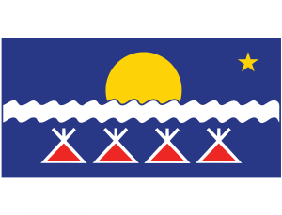

Mentor-Apprentice Program (MAP) Application Form
The goal of the Mentor-Apprentice Program (MAP) is to facilitate the development of new fluent Dehcho speakers where fluent speakers (mentors) are partnered with committed learners (apprentices) in an immersion environment in a home or on the land.
This will be a one-on-one language immersion program. The mentor and apprentice will spend at least 10 or more hours per week together doing everyday activities speaking Dene zhatié at all times. It is anticipated that the learners will become more fluent in Dene zhatié.
Both mentor and apprentice will receive an hourly stipend (up to 100 hours) for their efforts.

Application checklist
- All sections of the application form
- Mentor-Apprentice team agreement
- Training workshop worksheet to determine travel and accommodation needs

Eligibility
All Dehcho Dene learners and speakers 18 years old and over are eligible. Priority will be given to apprentices with a demonstrated commitment to share the language with others upon completion of the program. This includes teachers, childcare workers, parents, or those actively engaged in language programming in their community.

Program timeline
- Application submissions, deadline Friday, August 30, 2019.
- Application review and selection by Dehcho First Nations.
- Workshop, September 17-18, 2019 in Yellowknife.
- Attendance is mandatory for all MAP teams.
- Travel and accommodation will be covered.
- MAP implementation, from September 2019 to March 2020.
- Mentor and apprentice begin their language immersion sessions.
- Stipends will be issued upon submission of required reporting
by mentor-apprentice team every 50 hours of immersion time.

Section A: Contact Information
 | Apprentice | Mentor
Name:
Email:
Primary phone:
Mailing address:

Relationship between pair (if any):
Expected start and completion dates:
Location of work:
(e.g., mentor’s home, apprentice’s home, out in the community, outings on the land, etc.)

Section B: Mentor information
- Describe your level of fluency*, availability, and current involvement with the language, if any:

- Please indicate her/his commitment to working with the apprentice over the course of a year:

Section C: Apprentice information
- What is your current language level?
- Beginner (Have no language knowledge. May know some words and phrases such as colours, numbers, or greetings.)
- Low-intermediate (Have a little language knowledge, including basic phrases. Understand more than can speak.)
- Mid-intermediate (Have some language knowledge. Can have simple conversations in the language.)

- Are you a teacher or childhood educator? □ Yes □ No

If yes, please describe your current level of teaching certification:
(e.g., EA, BEd, Language teacher, other)

- Please describe your current employment /study, and plans for completing the program:
(i.e., plan to take time off work to complete the immersion hours every week)

- Please describe any past or present involvement with language-related activities:

- Please describe your overall language goals and how you plan to pass on the language:

Section D: Program outline
- Outline your schedule. Your team should complete approximately 10 hours or more of language immersion each week to a maximum of 100 paid hours for the program. Please also indicate a day and time that both the mentor and apprentice will be available to field a monthly call from the MAP coordinator.
 | Sun | Mon | Tues | Wed | Thurs | Fri | Sat | Total Hours
Week 1
Week 2
Week 3
Week 4
Week 5
Week 6
Week 7
Week 8
Week 9
Week 10
TOTAL HOURS PER MONTH

- Please list the language skills you plan to gain in the course of this program:
(e.g., listening, asking questions, simple conversations)

- Please list the topics or areas of interest you will focus on during this program:
(e.g., daily household activities, salutations and greetings, on the land activities)

Mentor-Apprentice Team Agreement
Please read the following statements regarding MAP and sign where appropriate.

- We understand that participation in MAP involves a commitment towards the Apprentice gaining fluency in our Indigenous language.

Mentor: Apprentice:

- We understand that MAP involves being immersed in our Indigenous language for significant portions of time during the learning period. We understand that it is recommended that we spend at least 100 immersion hours together.

Mentor: Apprentice:

- We understand that the two day training session in Yellowknife on September 17-18 is a required part of MAP and we both intend to participate.

Mentor: Apprentice:

- As the Apprentice, I understand that I will be responsible for maintaining regular contact (in person, via phone or email) with the MAP coordinator during our learning period and I will be responsible for submitting reports every 50 hours of immersion time for both of us to receive our allotted stipend.

Apprentice: Date:

- As the Apprentice, I understand that I will be evaluated at the end of the program on my language learning, comprehension, and speaking ability. The evaluation will be conducted by the MAP coordinator and a language specialist, as well as potentially other fluent speakers or language teachers. The mentor will not be part of the evaluation.

Apprentice: Date:

Training Workshop Worksheet
A mandatory training workshop will be held for mentor-apprentice teams on September 17 to 18, 2019 in Yellowknife. In order to cover travel and accommodations costs, please provide the following details:
Where will you be traveling from?
(residence/departure location)
How will you travel?
(road/air)
If you are driving, what is your total mileage?
(e.g., Behchokǫ̀ to Yellowknife is 200 km roundtrip)
Does your team require accommodations in Yellowknife? (September 16-20)
Would you be willing to share accommodations as a team or with other apprentices/mentors?

I declare that the information in this application is accurate and complete.

Mentor (NAME): Apprentice (NAME):

Signature: Signature:

Date: Date:

