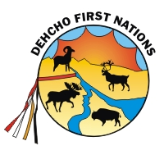
DEHCHO FIRST NATIONS
PO BOX 89, FORT SIMPSON, NT X0E 0N0
TEL: (867) 695-2610 FAX: (867) 695-2038/2927
Toll Free: 1-866-995-3748
Website: www.dehcho.org

DEHCHO FIRST NATIONS
BOARD AND COMMITTEE APPOINTMENTS

POSTED: OCTOBER 5, 2018

The Dehcho First Nations is seeking APPLICANTS for the following boards/committees:

- Great Slave Lake Technical Advisory
- Committee (3 Members)

- Dene Nation Health Committee (1 Member)

- Conference of Management Authorities (1 Member)

All terms of reference for each Committee or Board is available in your community Dene or Metis offices.

Please provide a cover letter, resume and criminal records check for the Board or Committee you are interested in.

Further inquiries can also be made by contacting Alison de Pelham, Executive Director at the above numbers or email at executivedirector@dehcho.org

Deadline for Submissions: November 15, 2018 at 5:00 PM

